
ACRN AI ENABLEMENT GUIDE
AI Brand Aligned Document Creation Guide
How to use the ACRN Corporate Identity Guide with AI tools so documents, files, presentations, and visual assets stay consistent.
Brand Source  ACRN Corporate Identity Guide v1.0, 2026 | Primary Users  Communications, operations, research, leadership | Core Rule  Use AI for speed; use the brand guide for control.

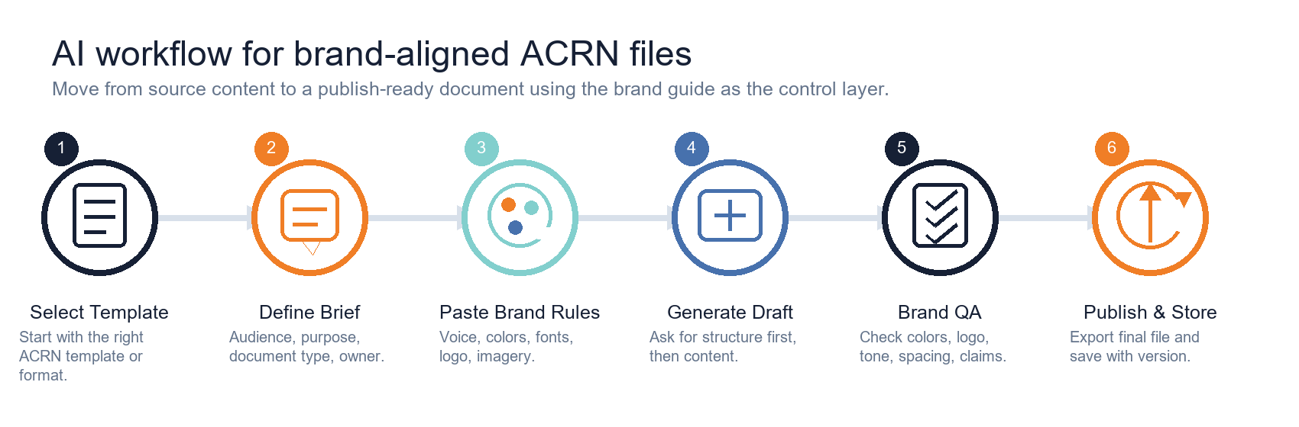
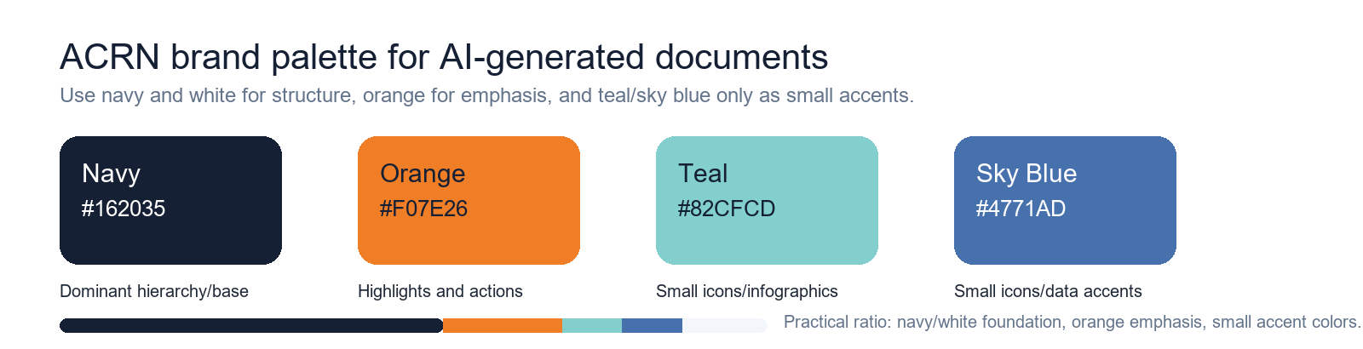

1. Quick Start
Use this sequence whenever AI is asked to create, edit, summarize, format, or redesign an ACRN document.
- Choose the intended file type first: report, SOP, agenda, slide deck, social graphic, email, or spreadsheet.
- Start from the closest official ACRN template whenever one exists.
- Paste the ACRN Brand Prompt Block before asking AI to draft.
- Ask AI to produce structure before full content for longer documents.
- Review against the Brand QA checklist before export, sharing, or publication.
Copy/Paste: ACRN Brand Prompt Block
You are creating an ACRN file or document. Follow ACRN Corporate Identity standards:
- Voice: professional, credible, warm, African-led, evidence-based, trusted, and informative rather than promotional.
- Color: Navy #162035 is the dominant hierarchy/base. Orange #F07E26 is for highlights and calls to action. Teal #82CFCD and Sky Blue #4771AD are only for small icons, infographics, or data accents.
- Typography: Futura PT for print where available. Poppins Regular, Semi-Bold, and Bold for digital documents. Use 32-40 pt for titles, 24-28 pt for subtitles, and 11-12 pt for body copy.
- Logo: use the official ACRN logo only. Do not stretch, recolor, crop incorrectly, add effects, rotate, or place it on low-contrast backgrounds.
- Visuals: use authentic African investigators, community engagement, and modern research infrastructure in warm natural light. Avoid stereotypes, generic stock images, and sensational claims.
- Graphic elements: use the Africa icon, parallel lines, and 25 degree angle device sparingly as structural accents.
- Output: keep copy clear, accessible, respectful, and aligned to the selected ACRN template.

Working rule
AI may suggest layouts, copy, icons, tables, and summaries. The final decision must still be checked against the brand guideline, the official template, and the intended audience.

2. Brand System Reference For AI
These are the brand rules that should be translated into AI prompts, document templates, and quality checks.

Brand Element | Rule To Give AI | Watch For
Voice | Professional, credible, warm, African-led, evidence-based, trusted. Informative rather than promotional. | Overpromising words such as first, best, game-changing, revolutionary, miracle, or guaranteed.
Color | Navy #162035 for structure. Orange #F07E26 for emphasis. Teal #82CFCD and Sky Blue #4771AD only as small accents. | AI adding random gradients, purple, neon, beige-heavy, or off-brand colors.
Typography | Poppins for digital and Futura PT for print where available. Keep body copy readable at 11-12 pt. | All caps body text, tight line spacing, mixed fonts, or tiny tables.
Logo | Use the official logo with safe space and correct contrast. | Stretching, recoloring, cropping, shadows, outlines, or placing the logo on busy imagery.
Graphic Devices | Africa icon, parallel lines, and 25 degree angle device. Use as subtle structure. | Decorative clutter, too many repeated shapes, or AI-generated fake logos.
Photography | Real people, authentic research settings, community engagement, and modern infrastructure in warm natural light. | Stereotypes, staged generic images, dark stock visuals, or imagery unrelated to clinical research.

3. Workflow: From AI Draft To Brand-Aligned File

Stage | What To Do | AI Instruction
1. Select template | Use the closest official ACRN Word, PowerPoint, email, or spreadsheet template. | Use this template structure and do not invent a new visual identity.
2. Define the brief | State audience, purpose, owner, length, format, confidentiality, and deadline. | Ask clarifying questions only if the missing information changes the content or approval path.
3. Apply brand rules | Paste the Brand Prompt Block and any document-specific constraints. | Use ACRN colors, voice, typography, and imagery rules throughout.
4. Generate structure | Ask for headings, sections, slide outline, table schema, or visual hierarchy before drafting. | Provide a concise structure first, then wait for approval before expanding.
5. Draft content | Generate text, tables, or visuals based on approved structure and source material. | Keep claims evidence-based and mark assumptions clearly.
6. QA and publish | Check the final against the QA checklist, export, save with version, and request approval where needed. | Run a brand, clarity, consistency, and accessibility check before final output.

4. Prompting Framework
For stronger results, give AI the same information you would give a designer, writer, or document controller.
1. Task  State the exact output: report, agenda, SOP, proposal, slide outline, social post, infographic, or spreadsheet note.  Specify whether you want structure, full draft, edit, summary, or QA. | 2. Audience  Name the reader: investigators, partners, community members, regulators, funders, internal team, or leadership.  Adjust detail, tone, and evidence level for that audience.
3. Source Material  Paste approved facts, notes, meeting outputs, data, references, and any non-negotiable wording.  Tell AI to flag gaps instead of inventing facts. | 4. Brand Rules  Paste the ACRN Brand Prompt Block.  Add the output-specific rules: logo placement, color emphasis, slide count, table style, or image guidance.
5. Constraints  Set length, page count, language level, file type, headings, and required sections.  Mention compliance, confidentiality, and approval route. | 6. QA Request  Ask AI to self-check for brand alignment, clarity, tone, accessibility, unsupported claims, and missing approvals.  Require a final checklist before publication.

Reusable prompt skeleton
Create a [document type] for [audience] about [topic/purpose]. Use the ACRN Brand Prompt Block. Base the content only on the source notes below. Keep the tone professional, credible, warm, African-led, evidence-based, and informative. Use headings, tables, and visual callouts where helpful. Do not invent facts. Flag assumptions. Finish with a brand QA checklist.
Source notes: [paste approved notes, figures, decisions, links, or transcript].
Output format: [Word-ready outline / slide outline / table / final draft / social copy / infographic brief].

5. File And Document Recipes
Use these recipes to translate the same brand system into different AI-assisted outputs.
Output | Use This Starting Point | Prompt AI To Emphasize | Final QA
Word report | ACRN Report Template | Executive summary, evidence, recommendations, clean tables, navy headings, orange highlights. | No unsupported claims; tables readable; correct cover metadata.
Proposal or concept note | ACRN Proposal / Concept Note Template | Problem, proposed solution, outcomes, partner value, budget summary, evidence base. | Tone is credible and funder-ready, not inflated.
Policy or SOP | ACRN Policy / SOP Template | Purpose, scope, definitions, responsibilities, procedure, records, approvals. | Numbering, version control, owners, effective dates.
Meeting agenda or minutes | ACRN Agenda / Minutes Templates | Decisions, owners, due dates, attendance, action log. | Action items are clear and attributable.
PowerPoint deck | ACRN PPT style from brand guideline | Short slide titles, one message per slide, navy base, orange emphasis, sparse teal/blue accents. | Slide count, visual consistency, logo placement.
Social graphic | Existing social asset style | Short copy, strong hierarchy, authentic image direction, limited palette. | Platform dimensions, legibility on mobile, no generic imagery.
Email signature | ACRN Email Signature Template | Name, role, contact fields, logo, orange divider. | Links, phone numbers, and title are current.
Spreadsheet or form | ACRN invoice/register/evaluation style | Clean labels, navy headers, orange section accents, readable table widths. | No cramped cells, formulas tested, protected where needed.

Template location
Use the editable files in ACRN_Office_Templates_2026 as the preferred starting point for Word, spreadsheet, and email outputs.

6. Visuals, Icons, Infographics, And Images
AI can help create visual structures, but the brand guideline controls what is acceptable.
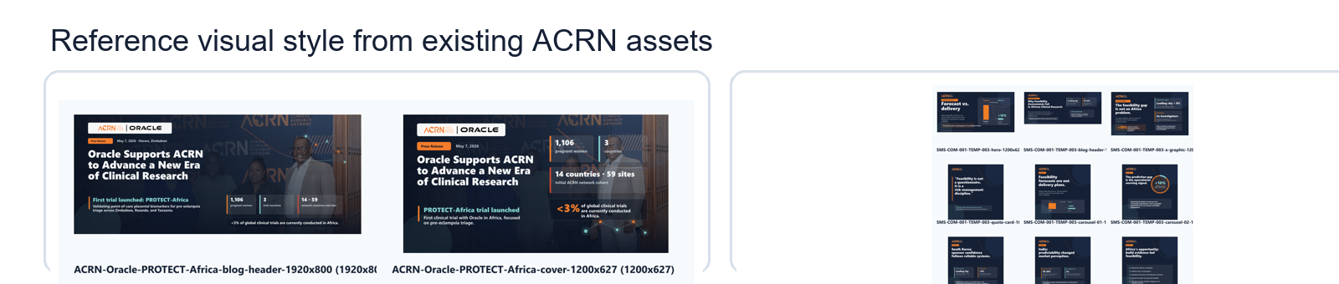
Asset Type | Use | Avoid
Logo | Official ACRN logo with clear safe space and strong contrast. | Fake logos, recolored logos, shadows, outlines, skewing, or crop damage.
Icons | Simple line icons in navy, orange, teal, or sky blue. Use for steps, checks, and infographics. | Mixed icon styles, multicolor clip art, or overly playful symbols.
Infographics | Use navy structure, orange highlights, and small teal/blue accents for categories or data points. | Rainbow palettes, complex 3D effects, dense text, or decorative clutter.
Photography | African investigators, community engagement, clinical research teams, labs, and infrastructure in warm natural light. | Stereotypes, generic hospital stock photos, dark moody imagery, or unrelated technology visuals.
Graphic devices | Parallel lines, Africa shape, and 25 degree angle device as subtle separators or section anchors. | Large repeated patterns that overpower the content.

Image generation / image search brief
Create or select imagery showing authentic African clinical research leadership, investigators, communities, laboratories, or modern research infrastructure. Use warm natural light, respectful composition, and professional credibility. Avoid stereotypes, sensationalism, staged stock-photo expressions, and imagery unrelated to clinical research.
For icons or infographics, use simple line icons in #162035, #F07E26, #82CFCD, or #4771AD only.

7. Brand QA Checklist
Run this before a file is sent to partners, published, printed, uploaded, or reused as a template.
Check | Pass Criteria
[ ] Purpose and audience | The document type, audience, and next action are clear on the first page or opening section.
[ ] Voice | Professional, credible, warm, African-led, evidence-based, and informative rather than promotional.
[ ] Colors | Navy and white provide structure; orange is used for emphasis; teal/sky blue are small accents only.
[ ] Typography | Poppins or Futura PT rules are followed where available; body text remains readable.
[ ] Logo | Official logo only, with safe space, correct proportions, and suitable contrast.
[ ] Imagery | Images are authentic, respectful, research-relevant, and not stereotyped.
[ ] Claims | No unsupported, exaggerated, or sensational claims. Assumptions are marked.
[ ] Layout | Adequate white space, readable tables, consistent headings, and no cramped sections.
[ ] Accessibility | Clear headings, meaningful alt text where possible, readable contrast, and plain language.
[ ] Version control | File name, date, owner, and approval status are clear.

AI QA prompt
Review this document against the ACRN Brand QA Checklist. Return a table with each check, pass/fail, issue found, and exact fix. Do not rewrite the document until I approve the fixes.

8. Common AI Mistakes And Fast Fixes
Mistake | Why It Breaks Brand | Fix Prompt
Too much orange | Orange is a highlight color, not the base. | Reduce orange to emphasis only. Use navy for hierarchy and white space for balance.
Generic global health stock image | It weakens African-led authenticity and may feel stereotyped. | Replace with authentic African clinical research, investigator, lab, site, or community engagement imagery.
Overpromising language | ACRN voice is evidence-based and trusted. | Rewrite to be informative and credible. Remove first, best, game-changing, revolutionary, and guaranteed.
Mixed fonts | It creates a fragmented identity. | Use Poppins for digital documents or Futura PT for print where available. Keep hierarchy consistent.
Crowded table | It reduces readability and polish. | Widen narrative columns, shorten headings, add padding, and reduce unnecessary fields.
Fake logo or icon style | AI-generated brand marks damage trust. | Use the official logo. Use simple line icons in the approved colors only.

Correction prompt
Revise this output to match ACRN brand standards. Keep the substance, but fix color usage, tone, typography guidance, heading hierarchy, table readability, and visual direction. List every brand issue you corrected.

9. Governance, Storage, And Approvals
AI-generated files should still follow normal ACRN document control and communications review.
File naming  Use a clear pattern: ACRN-[Department]-[DocumentName]-v[Version]-[YYYYMMDD].  Avoid vague names such as final_final, AI draft, or new version. | Approval status  Mark files as Draft, Internal Review, Approved, or Published.  Do not publish AI-generated content without the required owner or communications approval.
Source traceability  Keep the source notes, approved facts, and prompt used to generate the file where practical.  Ask AI to list assumptions and missing inputs. | Sensitive information  Remove personal data, confidential study information, and partner-sensitive details unless explicitly approved.  Use anonymized examples for training material.
Asset library  Use official logo, brand assets, and templates from the approved ACRN files.  Ask communications for asset approval or missing brand files. | Reuse  Turn successful prompts and layouts into reusable internal templates.  Update them when the brand guideline changes.

Final publishing prompt
Before I publish, check this file for ACRN brand alignment, unsupported claims, missing approvals, inconsistent names/dates, broken links, low-contrast text, and layout issues. Return only required fixes and a final publish/no-publish recommendation.

Appendix: Ready-To-Use Prompt Blocks
Word report prompt
Draft a Word-ready ACRN report for [audience] on [topic]. Use the ACRN Brand Prompt Block. Include an executive summary, background, objectives, findings, recommendations, action table, and next steps. Keep the tone evidence-based, warm, professional, and African-led. Use navy headings, orange emphasis, and readable tables. Do not invent facts; flag assumptions.

Slide deck prompt
Create a [number]-slide ACRN presentation outline for [audience] about [topic]. Use one message per slide. Use navy as the base, orange for highlights, and teal/sky blue only for small icons or data accents. Suggest authentic clinical research imagery. Include speaker notes and a final brand QA checklist.

Infographic prompt
Design a concise ACRN infographic concept explaining [process/data/topic]. Use simple line icons, the approved palette (#162035, #F07E26, #82CFCD, #4771AD), strong white space, and clear hierarchy. Avoid decorative clutter and unsupported claims. Provide copy, layout notes, icon suggestions, and accessibility notes.

SOP prompt
Create an ACRN SOP draft for [process]. Use Purpose, Scope, Definitions, Responsibilities, Procedure, Records, References, Version Control, and Approval sections. Keep wording precise, controlled, and operational. Mark assumptions and missing approvals. Use the ACRN Policy / SOP template style.

